

NOVAC TECHNOLOGY SOLUTIONS

User Manual

Document Version No.: 1.00

Revision History
Version No | Reason For Changes | Author | Approver
0.01 | Draft | RAVI
1.00 | Reviewed & Approved the User Manual | RAVI | NIJANTHAN PL

Table of Contents
1. Introduction 4
2. Block the unpaid expiry policy for own renewal 4

Introduction

The document is prepared to understand and build an application for Construction All Risks Insurance to the insured.

Block the Unpaid expiry Policy for Own renewal

- System is expected to validate at the time of own renewal whether the Premium is fully paid or not for expired policies in the Proposal entry screen.
- System should restrict the own renewal process and show the error messages as “Policy is expired and premium is pending XXXXX to paid” if the policy is expired and premium is unpaid.
- This validation is applicable for all products (Motor and Non-Motors).
- System should display the Outstanding Premium value in XXXXX

Path: Proposal Entry -> Motor Proposal Dashboard
Screen Code: S0024

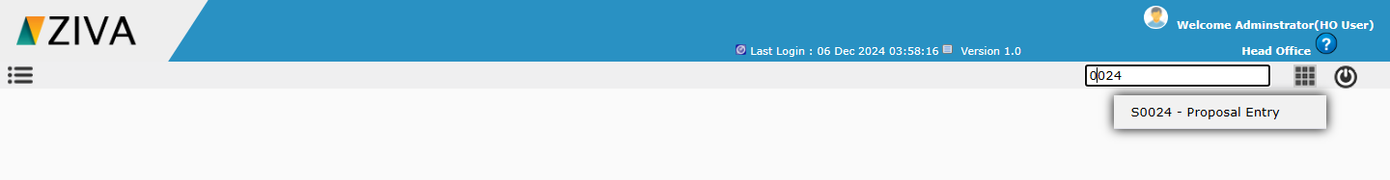

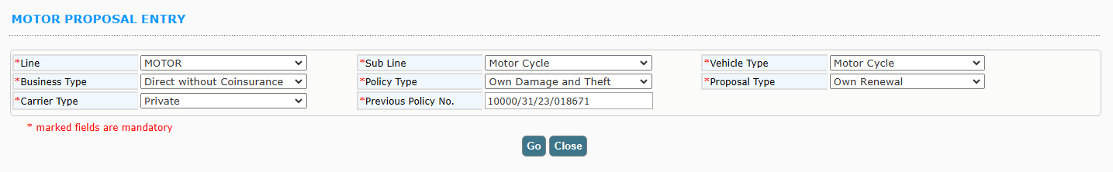
After selecting the Line, Sub Line, Vehicle Type, Business Type, Policy Type, Proposal Type, Carrier Type, and Previous Policy details, clicking the "Go" button should display a popup with pending payment details if the previous policy is unpaid.

